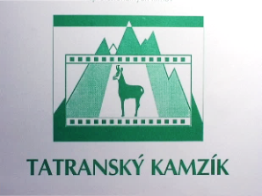
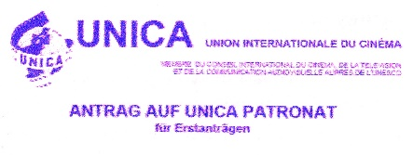
THE CHAMOIS OF THE TATRAS 2021
PROPOSITIONS of the 28th year’s volume of the international thematic contest of non-professional films
A. Basic data
Announcer: The town of Liptovský Hrádok
Organizational guarantor: ART ŠTÚDIO Liptovský Hrádok
Professional guarantor: Mgr. art. Miroslava Palanová
Co-organizers: Liptov Cultural Centre - Liptovský Mikuláš
and Nicolausfilm Liptovský Mikuláš
The Event Date: 22. – 23. 10. 2021
The Event Place: Liptovský Hrádok, The House of Culture
Contest web-address: abc.Lmn.sk/kamzik21
Basic characteristic
THE CHAMOIS OF THE TATRAS 2021 is the 28th year’s volume of the international thematic competition of non-professional films. The authors submit their works directly to the organizational guarantor of the event. Before the main competition a selection process will be held.
Mission of the contest
The main mission of the event is the presentation and support of production, an effort to activate non-professional filmmakers, to encourage the creation of works from the following thematic areas: culture, art, ecology, lifestyle and ethnography. This type of work documents and visually archives many rare, often gradually disappearing things, events, work procedures or customs. The archive of this long-standing competition is rich in a number of unique records, documents and reports. The organization of the next year of the competition will contribute to maintaining the continuity of such thematically focused work in Slovakia and will enable a meeting and acquaintance with similarly oriented works from abroad.
B. The course of the contest
Categorization of participants
- The competition is one-round and every amateur film-maker, citizen of the Slovak Republic, as well as authors from abroad, can take part in it. The competition is divided according to age criteria and thematic focus of contributions (works). Each contestant can submit their works in individual categories.
- Age groups of competitors: A – 15-18 years, B – from the age of 19 (completion of 19 years no later than the closing date)
- In each age group you can compete in the following categories:
Competition categories
  - I. Culture and epoch-mark monuments – in this category, films depicting the history and cultural monuments in their entirety, especially folk culture, crafts, architecture, folk customs, folklore and medallions of creators compete;
  - II. Creation and protection of the living environment – in this category, films depicting natural beauties, films about the creation and protection of nature (protected fauna, flora) and the (living) environment (water, soil, air, greenery, waste as a source of secondary raw materials and their use) compete;
  - III. The current way of life of people – in this category, films that show the current way of life of people of different ages and social groups in different agglomerations (solitudes, settlements, villages, cities, travelogues) compete.
Organizational support and management of the competition
- the competition takes place every two years
- non-professional creators from all over the world can submit their films in the competition
- within the competition show, following educational activities will take place:
  - evaluation and analysis seminar
  - city tour to get to know it (arboretum, castle and manor house, museum, gallery of insit art, historic linden alley)
  - cultural program of the folklore ensemble Cindruška and Majerán
- the competition participant is reimbursed for accommodation with breakfast (1 night from Friday to Saturday); if the participant is interested in booking accommodation for another night at his own expense, the request must be stated in the application.
Participation terms and conditions
- the authors submit their works directly to the address of the organizational guarantor of the event;
- each author can send max. 2 films in each thematic category
- the competition is opened to non-commercial films only;
- two groups of film-makers compete: A - authors aged 15-18, B - authors from 19 years (inclusive), non-professional film-makers and students as well as high school and university graduates who did not / do not have a domain, field, area, department or subject focused on film production in the study program;
- contest films go through a selection process. The public competition screening will include those works that correspond to the thematic focus of the competition and are at a quality artistic and technical level. Only films that did not participate in this competition yet will be accepted;
- the jury reserves the right to limit the number of films for time reasons;
- authors whose film has passed the selection process will be personally informed of the result by e-mail. The results of the selection process will also be published on the filmdat.cz website
- classification by age group and category is indicated by authors themselves on the application form and confirmed by their signature;
- the recommended length of the competition films is up to 20 minutes
- a participation fee of 5,- eur is to be sent for each film in the shipment, or it could be paid by the participant at the presentation, or it could be credited to the account of the OZ ART ŠTÚDIO organization:
  - IBAN SK51 0200 0000 0027 7124 6155
  - enter the name and surname of the author in the 'message for the recipient' field.
- each film in a language other than Slovak or Czech must have subtitles or a commentary sent with the application form, as well as a separate annotation of max. 60 words, all in English
- authors under the age of 16 can only personally participate in the event if accompanied by an adult (parent, teacher)
Technical terms and conditions
- Only DVDs and flash drives will be accepted for physical movie submission. When choosing a media, keep in mind that media will not be returned by mail.
- For DVDs only DVD-video format will be accepted.
- All films must be in the PAL colour standard at a frequency of 25 fps (25p or 50i).
- Video formats: MP4, MPG2, AVI – minimum resolution 720 × 576, maximum resolution 1920 × 1080
- Films submitted in other formats may not be accepted for the contest.
- The film file and the medium carrier must contain at least: film title, author’s name, place of residence.
- In the application the author fills in the following information:
  - name of the film,
  - brief content of the film,
  - projection length and TV format (4:3, 16:9, other),
  - age group,
  - date of birth,
  - category,
  - name and surname of the author,
  - address: street, town, city, postcode,
  - author’s e-mail address,
  - author’s tel. number.
- Each film must be delivered as a separate file and must have at least 5 seconds of black at the beginning and at the end.
- The film together with the application can also be sent via the data service of the portal www.uschovna.cz or www.wetransfer.com to the e-mail address specified in the final provisions of these propositions.
- Movies hosted on YouTube, Stream, Vimeo and similar providers will not be downloaded and accepted by the organizer.

Time schedule of the contest
Competition part:
- 24. 9. 2021 - films registration and delivery deadline
- 27.-28. 9 - selection process
- do 1. 10. 2021 - notification to authors of the acceptance / non-acceptance of films
- 8. 10. 2021 - accommodation applications deadline
- 21. 10. 2021 - projection for schools in/of the town of Liptovský Hrádok
- 22. – 23. 10. 2021 - date of attendance competition
Non-competitive - educational part:
- Films analysis - the date will be specified during the event
Financial support
The event will be financially supported by the self-governing Žilina region and the City of Liptovský Hrádok. We will also ask for contributions from the foundation and sponsors.
Method of evaluation / assessment
The competition films are evaluated by a three-member international expert jury appointed by the organizing guarantor. The expert jury proposes the winning and awarded films of the competition to the organizers.
Awards
In both groups of authors, the organizer will award one Main Prize of the Mayor of the town of Liptovský Hrádok for the best film on the proposal of an expert jury, and in each category he will propose 1st, 2nd and 3rd place and honourable mentions. Material prizes shall not be sent to non-present authors. However, they can pick them up in person at the organizational guarantor until the end of 2021. The organizer has the right, at the proposal of the jury, not to award any of the award positions or to redistribute them. Thanks to the patronage of UNICA, it will also be possible to award the medal to the UNICA film, which will most accurately depict alliance and cooperation between nations with its content.
Contest results
At the ceremony, the organizers will announce the results of the competition and present the prizes to the winners. The result list will be published by the organizers on the LKS website - www.lks.sk and www.filmdat.cz website.
Final provisions
- Applications and competition works (films/movies) must be sent to the organizer's address:
- ART STUDIO Liptovský Hrádok, Kompiš Ľubomír, Liptovský Peter 27, 033 01 Liptovský Hrádok
- e-mail: tatranskykamzik2021@gmail.com
- Informations at tel. no.: +421 903 465 493 (Mr. Ľubomír Kompiš), +421 905 266 219 (Mrs. Danica Žiaková) or by e-mail at: lubor.patsch@gmail.com
- All competition films will be archived in the Chamois of the Tatras contest film library and the organizers guarantee that they will not be made copies for commercial use.
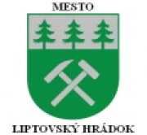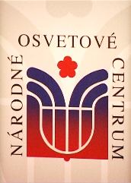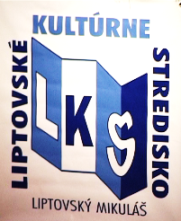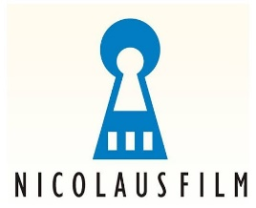
Note: In the event the contest cannot be held in the attendance form, we will announce the competition online in time (by September 24, 2021).

